**Instagram Analysis using Python – case study**

**Summary –** Analyzed Instagram data from csv file.

Analyzed and compared data by using different plots, pie, wordcloud, scatter plot.

**Analysis** – Posts reaching followers on Instagram are most likely to be on home screen. The hashtags need be modified based on followers interest.

**Data -** 

Code

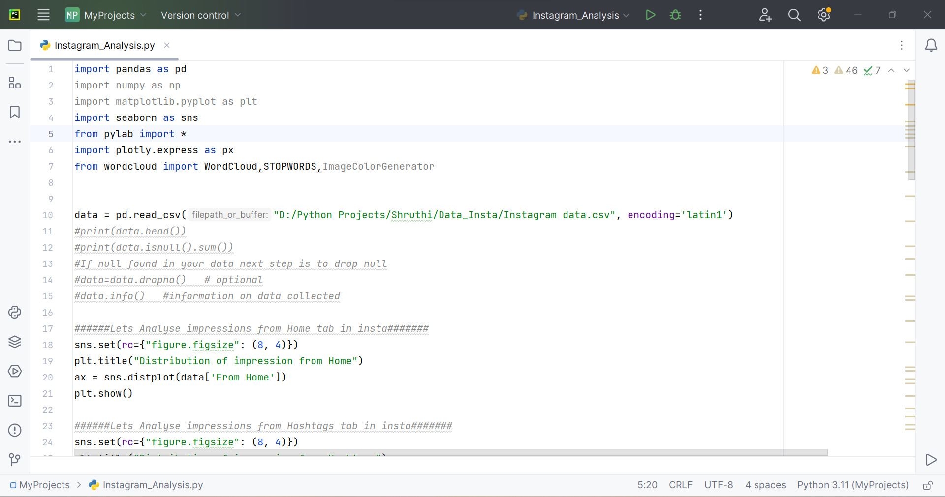

Impression analysis from home screen of Instagram

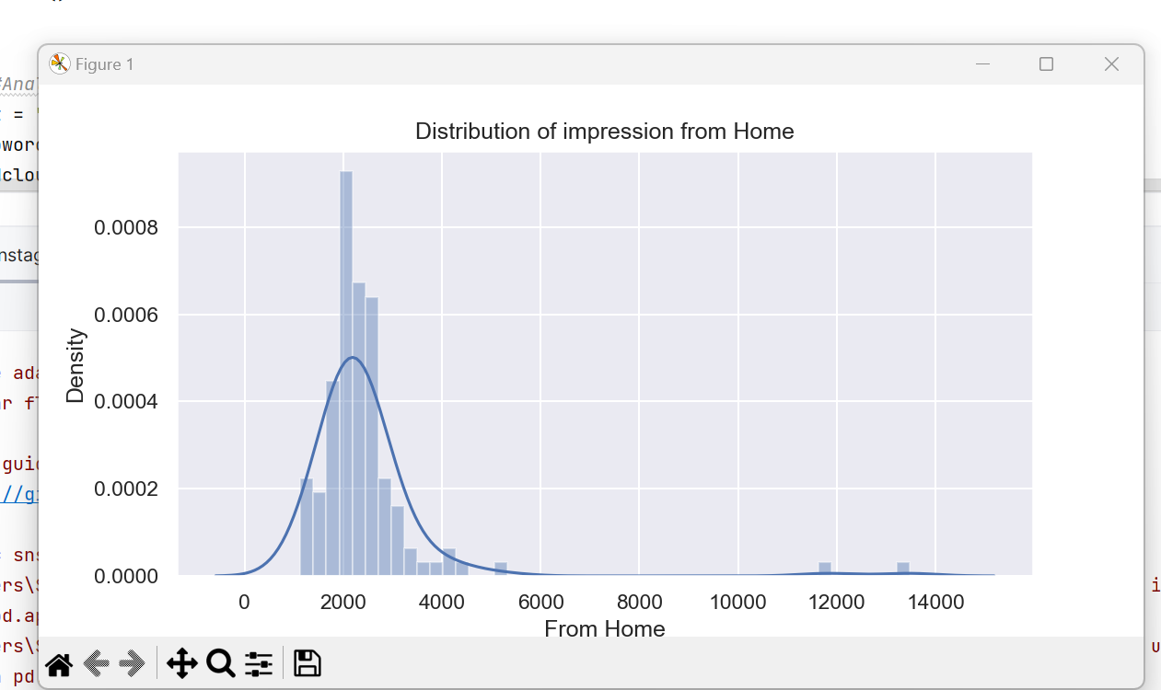

**Analysis** – the impressions are not reaching all followers from home screen

Impression analysis from Hashtags of Instagram

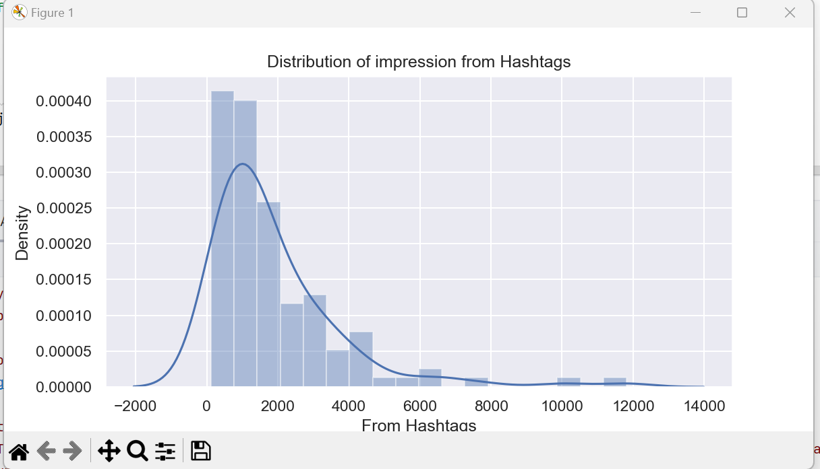

**Analysis** – used hashtag are not reaching people

Impression analysis from Explore screen of Instagram

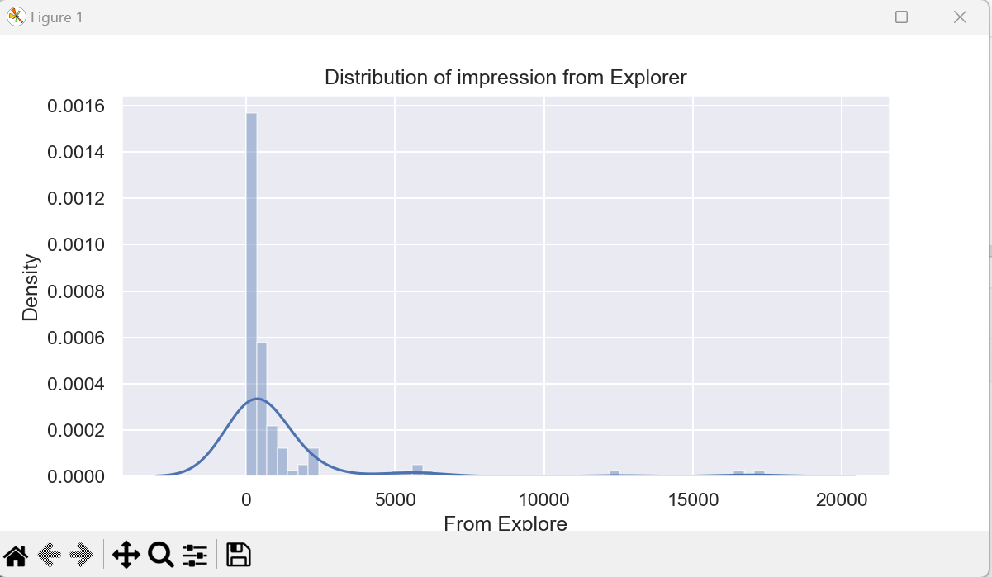

**Analysis** – hashtags are better than explore

Percentage analysis of different sources using donut chart

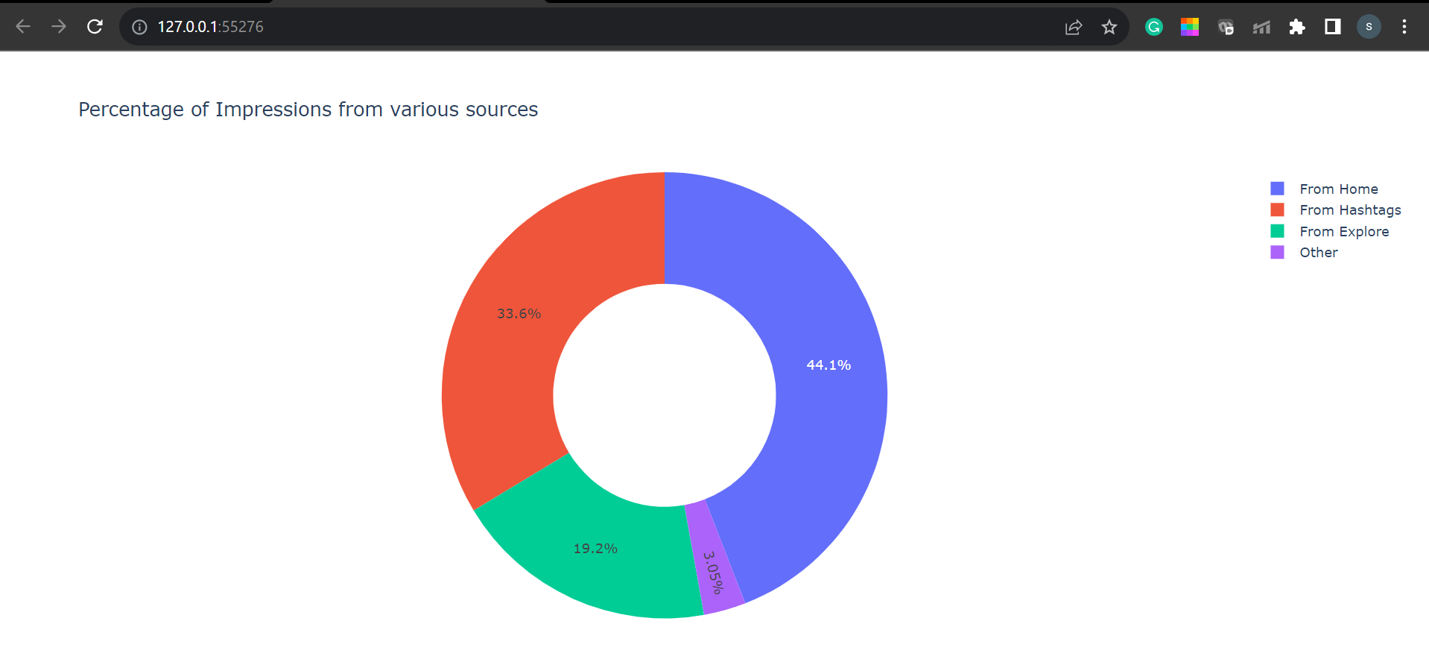

Donut chart gives a clarity which screen is reaching followers the most

Used wordcloud of the caption column to look at the most used words in the caption of Instagram posts

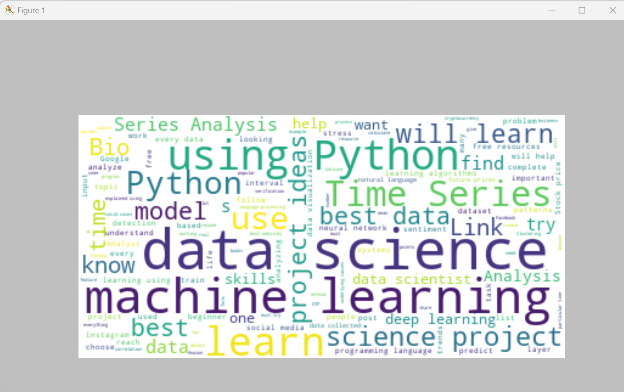

Used wordcloud of the caption column to look at the most used words in the hashtags of Instagram posts

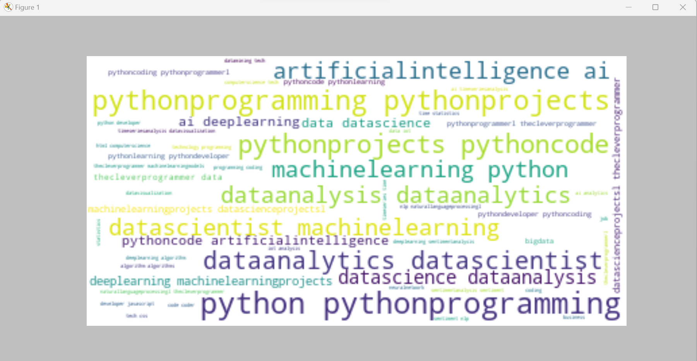

Linear relationships by scatter plots

Scatter plot to find relationship between likes and impressions

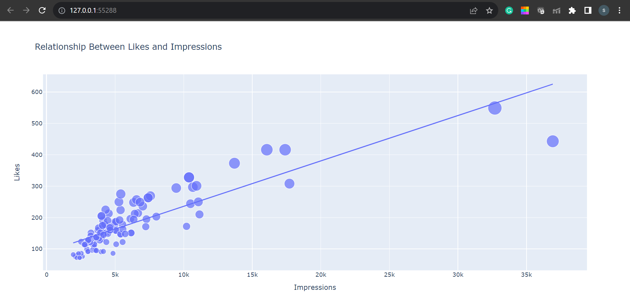

Scatter plot to find relationship between comments and impressions

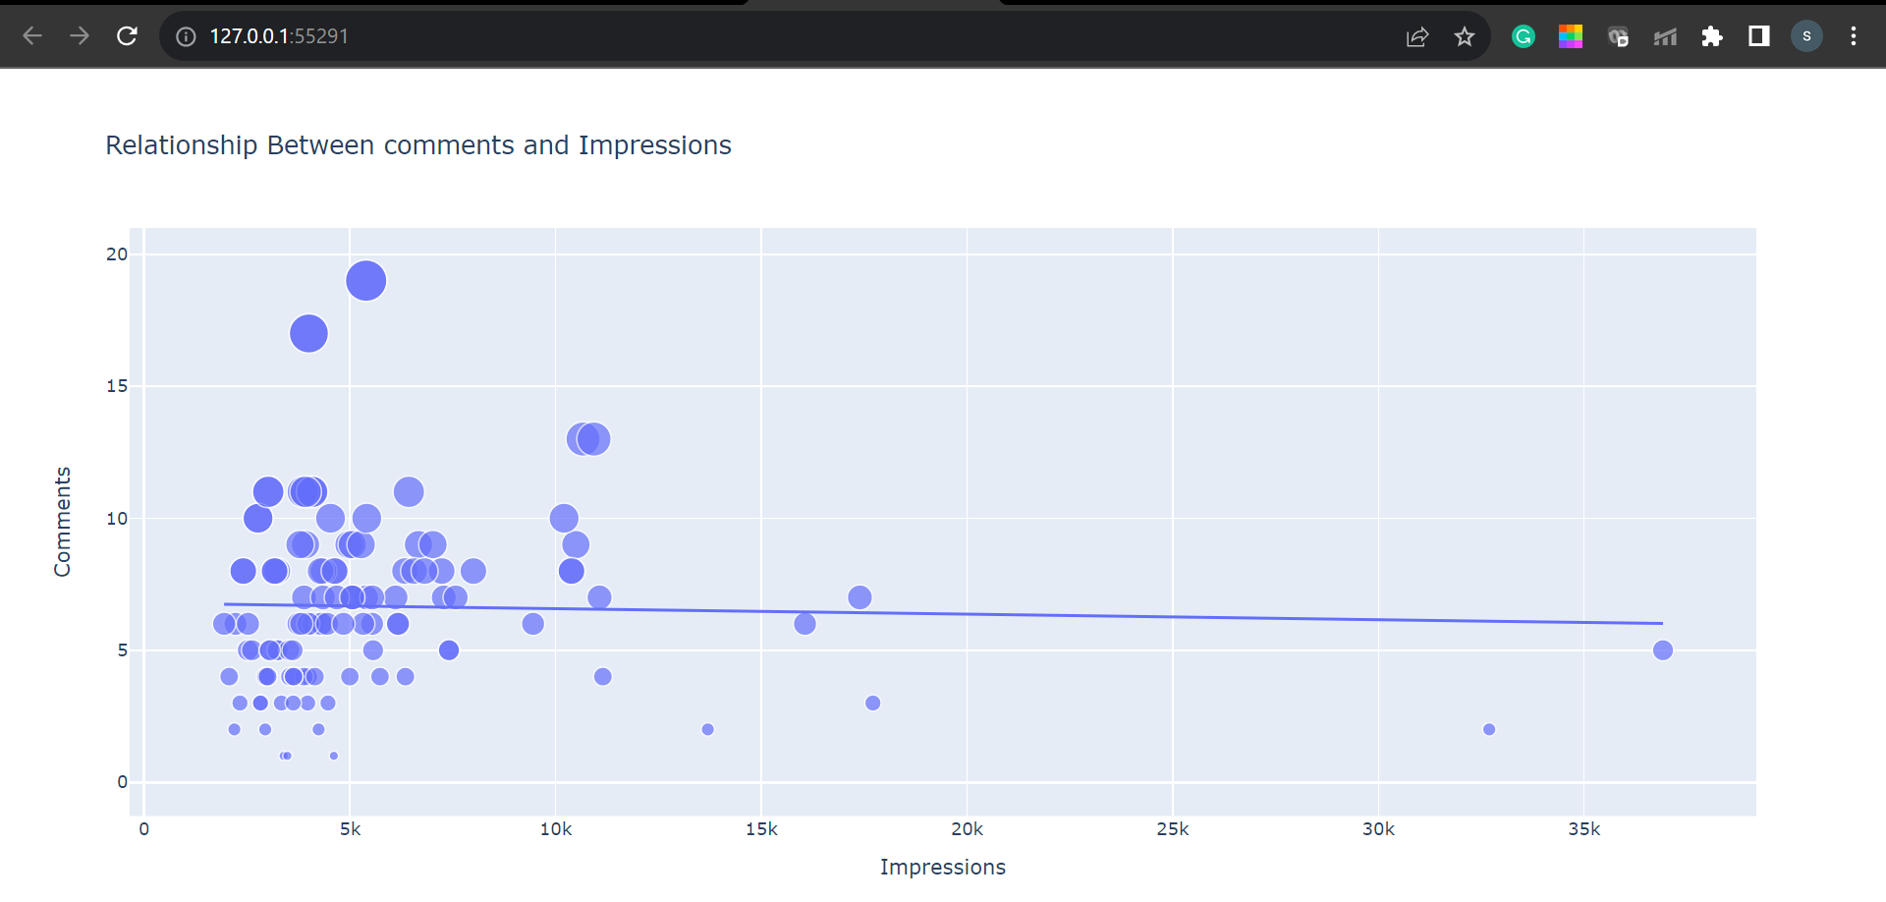

Scatter plot to find relationship between profile visits and Followers gained

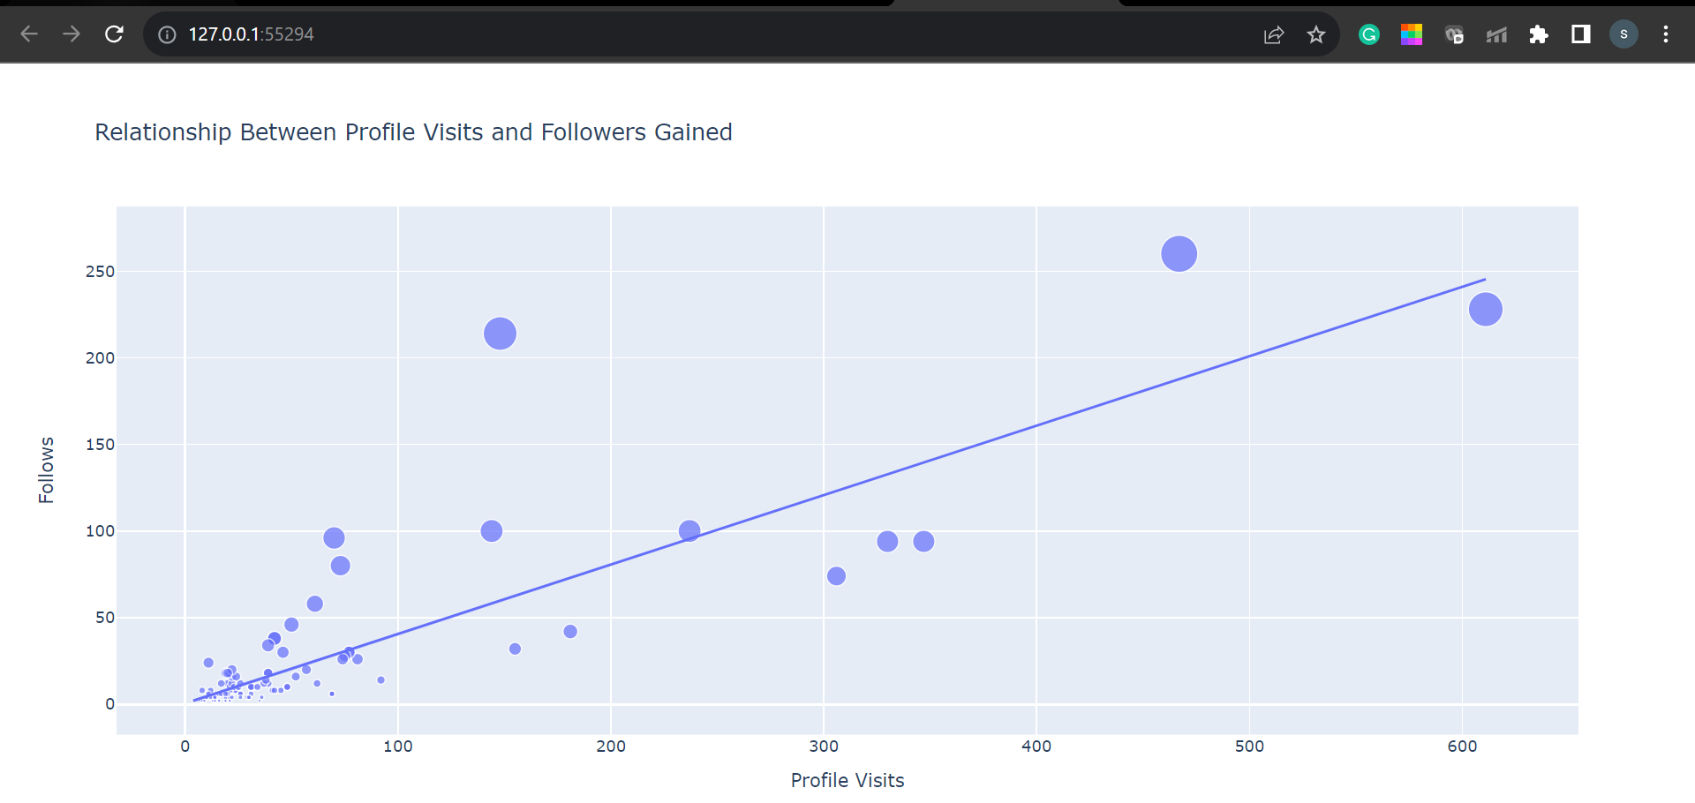

Scatter plot to find relationship between shares and impressions

